 | Assignment No. 02  Semester: Fall 2020  CS601: Data Communication |  | Total Marks: 20  Due Date: 15/12/2020
Tamkeeen Sajjad
MC200400003

Assignment

Question No. 1

Diagram given below is representing the Differential Manchester encoding scheme. You are required to carefully analyze the diagram and then write the binary pattern represented by the diagram:

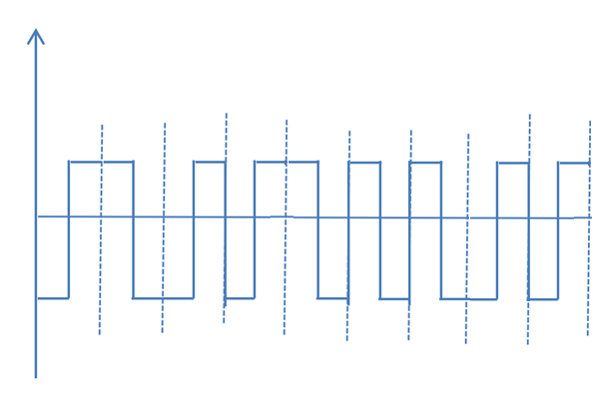
Answer No. 1
In Differential Manchester encoding, the transition at the middle of the bit is used only for the synchronization. The bit representation is defined by the inversion “bit 0” or the noninversion “bit 1” at the beginning of the bit. Therefore, this scheme is as follows:

0 | 1 | 1 | 0 | 1 | 0 | 0 | 1 | 0

Question No. 2

Suppose a telecommunication company’s booster is emitting a signal of 0.45W, which is being passed through 10 devices. It has been observed that 7 of these devices are encountering noise of 3 microwatts whereas other 3 devices are encountering noise of 2 microwatts. Considering this information, you are required to calculate overall Signal to Noise Ratio (SNR) and SNR_{dB} by writing all necessary formulas and calculation steps.
Answer No. 2
Signal Power = 0.45W
Noise Power of 7 devices = 7 x 3uW = 21uW
Noise Power of 3 devices = 3 x 2uW = 6uW
Total Noise Power = 21+6 = 27uW
SNR = S/N = 0.45W/27uW = 16,666.67
Now calculate SNR(db):
SNR(db) = 10 log₁₀ (16,666.67)
SNR(db) = 10 x 4.22
SNR(db) = 42.2

